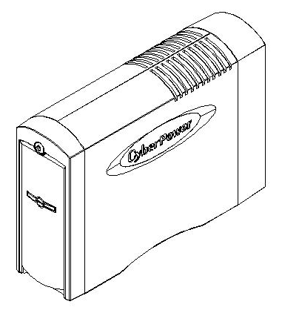

Executive LCD Compact UPS
CP1350EAVRLCD/CP1500EAVRLCD
User’s Manual

IMPORTANT SAFETY INSTRUCTIONS

This manual contains important instructions that should be followed during installation and
maintenance of the UPS and batteries. Please read and follow all instructions carefully during
installation and operation of the unit. Read this manual thoroughly before attempting to
unpack, install, or operate.
CAUTION! The UPS must be connected to a grounded AC power outlet with fuse or circuit
breaker protection. DO NOT plug the UPS into an outlet that is not grounded. If you need to
de-energize this equipment, turn off and unplug the UPS.
CAUTION! DO NOT USE FOR MEDICAL OR LIFE SUPPORT EQUIPMENT! CyberPower
Systems does not sell products for life support or medical applications. DO NOT use in any
circumstance that would affect the operation or safety of any life support equipment, with any
medical applications, or patient care.
CAUTION! The battery can energize hazardous live parts inside even when the AC input
power is disconnected.
CAUTION! To prevent the risk of fire or electric shock, install in a temperature and humidity
controlled indoor area, free of conductive contaminants. (Please see specifications for
acceptable temperature and humidity range).
CAUTION! To reduce the risk of electric shock, do not remove the cover, except to service
the battery. There are no user serviceable parts inside, except for the battery.
CAUTION! To avoid electrical shock, turn off the unit and unplug it from the AC power source
before servicing the battery or installing a computer component.
CAUTION! DO NOT USE WITH OR NEAR AQUARIUMS! To reduce the risk of fire, do not
use with or near aquariums. Condensation from the aquarium can come in contact with metal
electrical contacts and cause the machine to short out.
CAUTION! DO NOT USE WITH LASER PRINTERS! The power demands of laser printers
are too large for a UPS.

INSTALLING YOUR UPS SYSTEM

UNPACKING
The box should contain the following:
(1) PowerPanel® Personal Edition software (CD) x1; (2) USB cable (A+B type) x1; (3) Telephone communication cable x1; (4) Power cord x2; (5) user manual x1; (6) UPS unit x1.
OVERVIEW
The CP1350EAVRLCD/ CP1500EAVRLCD provides automatic voltage regulation for
inconsistent utility power. The CP1350EAVRLCD/ CP1500EAVRLCD features 1215 Joules
of surge protection, and provides battery backup during power outages. The
CP1350EAVRLCD/ CP1500EAVRLCD ensures consistent power to your computer system
and its included software will automatically save your open files and shutdown your computer
system during a utility power loss.
HOW TO DETERMINE THE POWER REQUIREMENTS OF YOUR
EQUIPMENT
1.Make sure that the total Volt-Amp (VA) requirements of your computer, monitor, and
peripheral equipment does not exceed 1350 VA/ 1500VA.
2.Ensure that the equipment plugged into the four battery power-supplied/surge outlets does
not exceed the UPS unit's rated capacity (1350VA/810W for CP1350EAVRLCD, 1500VA
/900W for CP1500EAVRLCD). If the rated unit capacities are exceeded, an overload
condition may occur and cause the UPS unit to shut down and the circuit breaker to trip.
3.If the power requirements of your equipment are listed in units other than Volt-Amps (VA),
convert Watts (W) or Amps (A) into VA by performing the calculations below. Note: The
equation listed below only calculates the maximum amount of VA that the equipment can
use, not what is typically used by the equipment at given time. Users should expect usage
requirements to be approximately 60% of the maximum power requirements:
Watts (W) x 1.67 = VA or Amps (A) x 230 = VA
Add the totals up for all pieces of equipment and multiply this total by 0.6 to calculate the
approximate requirements.
There are many factors that can affect the amount of power that your computer system will
require. The total load that you will be placing on the battery-powered outlets should not
exceed 80% of the unit's capacity.

BASIC OPERATION

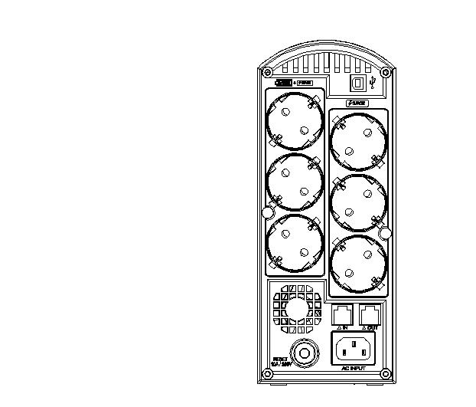
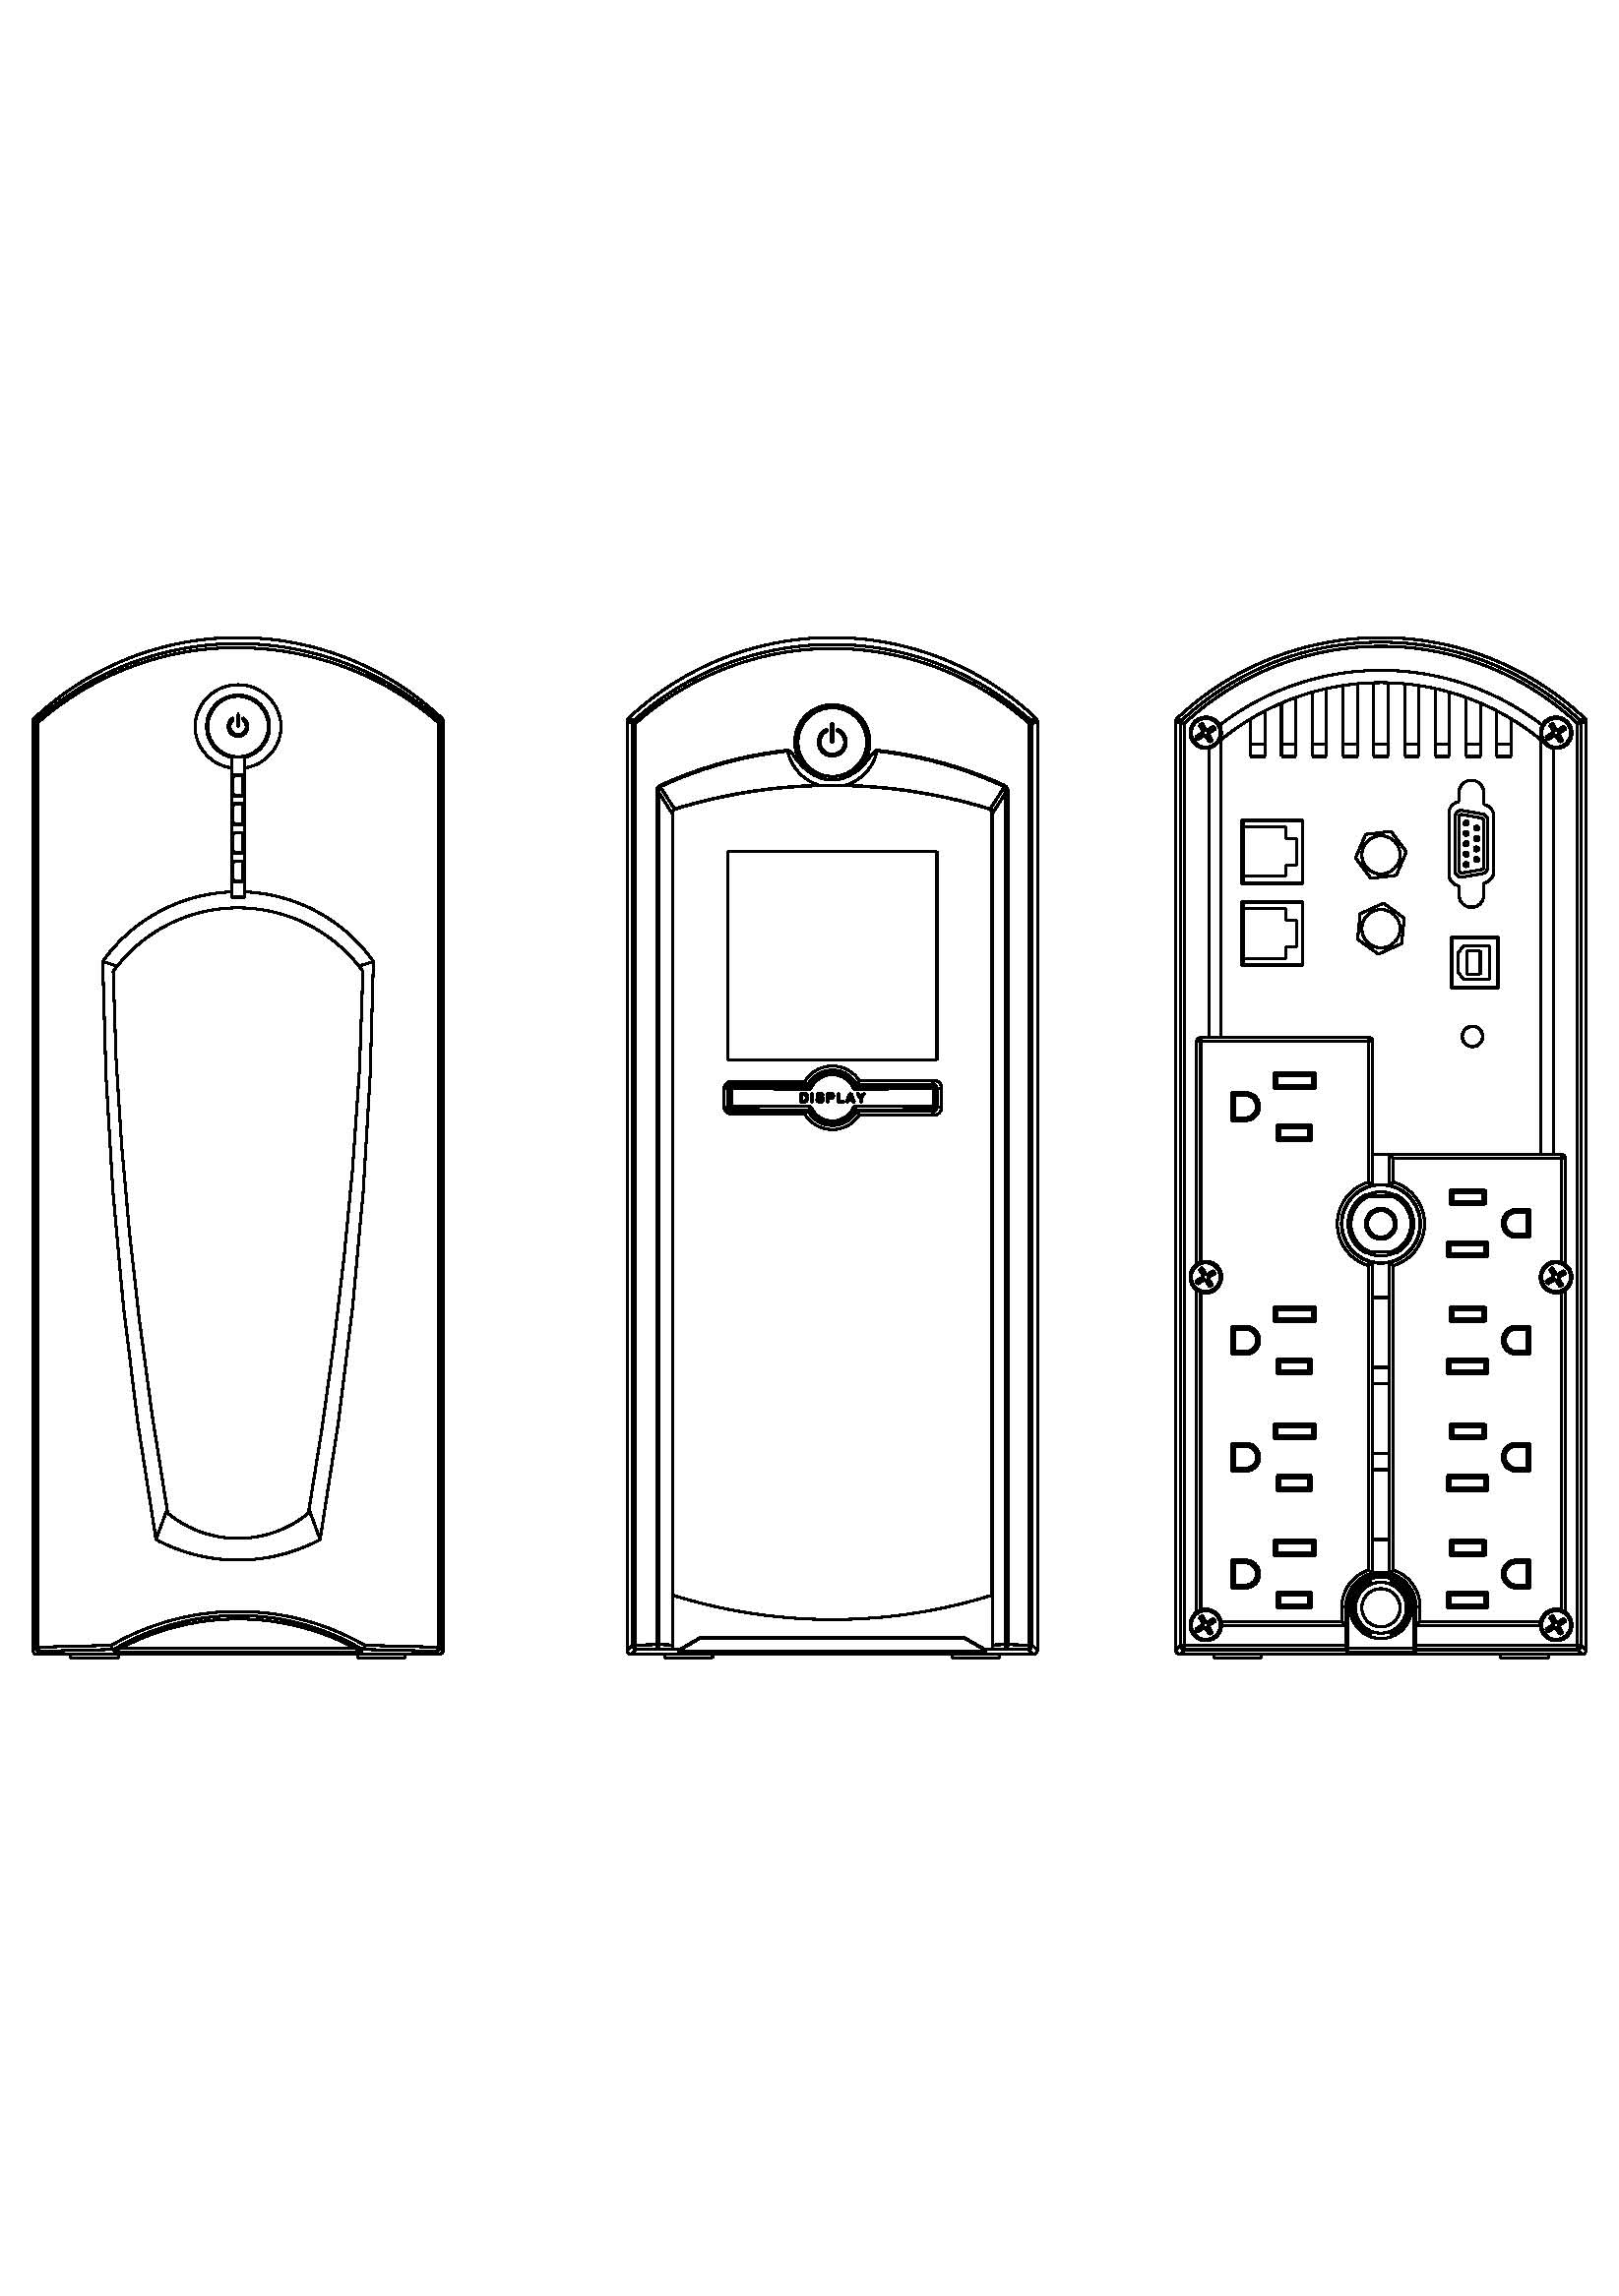
DESCRIPTION
①
②
③
④
⑤
⑧

⑨

⑩

⑦
⑥
- Power Switch
Used as the master on/off switch for equipment
connected to the battery power supplied outlets.
- Power On Indicator
This LED is under the power switch. It illuminates when the UPS outlets are providing power, free of surges and spikes.
- LCD Module Display
High resolution and intelligent LCD display shows all the UPS information with icons and messages. For more information please check the “Definitions for Illuminated LCD Indicators” section.
- LCD Display Toggle/Selected Switch
The switch can be used to select the LCD display contents including Input Voltage, Output Voltage and Estimated Run Time. The toggle frequency is set to one time per second. Holding the switch for more than two seconds while running on battery will silence the buzzer.
- USB Ports to PC
The USB port allow communication from the UPS to the computer. The UPS communicates its status to the PowerPanel® Personal Edition software when connected with a USB port.
- Battery and Surge Protected Outlets
The unit has four battery powered/surge protected outlets for connected equipment and ensures temporary uninterrupted operation of your equipment during a power failure.
- Full-Time Surge Protection Outlets
The unit has four always on surge suppression outlets.
- Communication Protection Ports
Communication protection ports will protect any standard modem, fax, telephone line, broadband network or Ethernet connection.
- AC Input
Connect the AC Power cord to a properly wired and grounded outlet.
- Circuit Breaker
Located on the side of the UPS, the circuit breaker serves to provide overload and fault protection.
Hardware Installation Guide

1. Your new UPS may be used immediately upon receipt. However, recharging the battery for
at least four hours is recommended to ensure that the battery's maximum charge capacity
is achieved. Charge loss may occur during shipping and storage. To recharge the battery,
simply leave the unit plugged into an AC outlet. The unit will charge in both the on and off
position.
2. If you will use the software, connect the USB cable to the USB port on the UPS.
3. With the UPS unit off and unplugged, connect the computer, monitor, and any externally
powered data storage device (Zip drive, Jazz drive, Tape drive, etc. into the battery power
supplied outlets. DO NOT plug a laser printer, copier, space heater, vacuum, paper
shredder or other large electrical device into the UPS. The power demands of these
devices will overload and possibly damage the unit.
4. To protect a fax, telephone, modem line or network cable, connect a telephone cable or
network cable from the wall jack outlet to the IN jack of the UPS. Then connect a telephone
cable or network cable from the OUT jack on the UPS to the modem, computer, telephone,
fax machine, or network device.
5. Plug the UPS into a 2 pole, 3 wire grounded receptacle (wall outlet). Make sure the wall
branch outlet is protected by a fuse or circuit breaker and does not service equipment with
large electrical demands (e.g. air conditioner, refrigerator, copier, etc. Avoid using
extension cords. If used, the extension cord must be grounded and rated for 15 amps.
6. Depress the power switch to turn the unit on. The power on indicator light will illuminate
and the unit will "beep" once.
7. If an overload is detected, an audible alarm will sound and the unit will emit one long beep.
To correct this, turn the UPS off and unplug at least one piece of equipment from the
battery power supplied outlets. Wait 10 seconds. Make sure the circuit breaker is
depressed and then turn the UPS on.
8. Your UPS is equipped with an auto-charge feature. When the UPS is plugged into an AC
outlet, the battery will automatically recharge.
9. To maintain optimal battery charge, leave the UPS plugged into an AC outlet at all times.
10. To store your UPS for an extended period, cover it and store with the battery fully
charged. Recharge the battery every three months to ensure battery life.

CYBERPOWER GREENPOWER UPS TECHNOLOGY


Our new UPS circuit is designed to save energy operating in GreenPower Bypass Mode.
A traditional UPS circuit with AVR provides normal output voltage through the Relay and AVR transformer. The current travels first through the transformer conducting energy and generating heat. This heat creates energy dissipation resulting in a "Power Loss" or consumption of utility power and money.
CyberPower's GreenPower Circuit Design is a solution to this "Power Loss." When the Utility Power is
operating normally, our Green Power UPS works in Bypass Mode. Our GreenPower design conducts power only through the Relay and still provides normal output voltage. Bypassing the transformer reduces power consumption thereby conserving energy and saving money. When the utility power is abnormal the UPS will operate under Battery or AVR Mode. Under this condition Green Power UPS and a traditional UPS would operate about the same.
On average utility power operates 88% of the time and the CyberPower GreenPower Technology will work in its money/energy saving Bypass Mode.

BATTERY REPLACMENT

CAUTION! Read and follow the IMPORTANT SAFETY INSTRUCTIONS before servicing the
battery. Service the battery under the supervision of personnel knowledgeable of
batteries and their precautions.
CAUTION! Use only the specified type of battery. See your dealer for replacement batteries.
CAUTION! The battery may present the risk of electrical shock. Do not dispose of batteries in
a fire, as they may explode. Follow all local ordinances regarding proper disposal of batteries.
CAUTION! Do not open or mutilate the batteries. Released electrolyte is harmful to the skin
and eyes and may be toxic.
CAUTION! A battery can present a high risk of short circuit current and electrical shock. Take
the following precautions before replacing the battery:
1. Remove all watches, rings or other metal objects.
2. Only use tools with insulated handles.
3. DO NOT lay tools or other metal parts on top of battery or any battery terminals.
4. Wear rubber gloves and boots.
5. Determine if the battery is inadvertently grounded. If inadvertently grounded, remove source
of ground. CONTACT WITH A GROUNDED BATTERY CAN RESULT IN ELECTRICAL
SHOCK! The likelihood of such shock will be reduced if such grounds are removed during
installation and maintenance (applicable to a UPS and a remote battery supply not having a
grounded circuit)

BATTERY REPLACEMENT PROCEDURE:
1. Turn off and unplug all connected equipment.
2. Turn the UPS off and unplug it from the AC
power source.
3. Turn the UPS upside down.
4. Remove the retaining screw.
5. Slide the battery compartment cover (front panel) completely
off of the unit.
6. Remove the batteries from the compartment.
7. Disconnect the battery wires from the batteries.
8. Install the replacement batteries by connecting the red wire
and black wire to the same color wires from the battery
pack.
9. Put the batteries back into the compartment.
10. Slide back the battery compartment cover and tighten the
retaining screw.
11. Recharge the UPS for 8-16 hours to fully charge the battery.

REMINDER: Batteries are consider HAZARDOUS WASTE and must be disposed of properly. Almost any retailer that sells lead-acid batteries collects used batteries for recycling, as required by most state laws.
DEFINITIONS FOR ILLUMINATED LCD INDICATORS

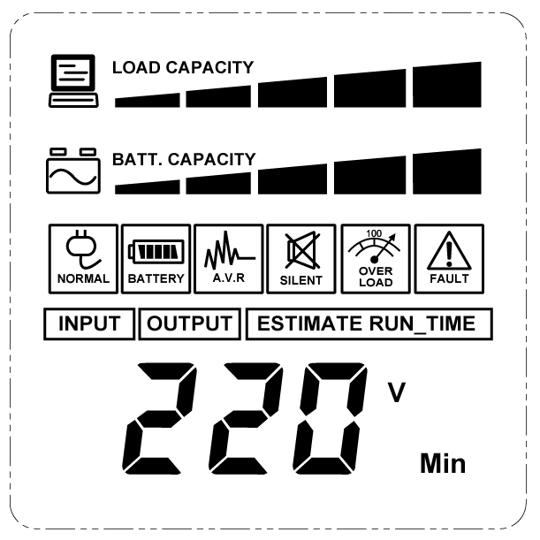
INPUT voltage meter: This meter measures the AC voltage that the UPS system is receiving from the utility wall outlet. The UPS is designed, through the use of automatic voltage regulation, to continuously supply connected equipment with stable, 220/230 output voltage. In the event of a complete power loss, severe brownout, or over-voltage, the UPS relies on its internal battery to supply consistent 220/230 output voltage. The
INPUT voltage meter can be used as a diagnostic tool to identify poor-quality input power.
OUTPUT voltage meter: This meter measures the AC voltage that the UPS system is providing to the computer, such as normal line mode, AVR mode, and battery back up mode.
Note: The OUTPUT voltage meter shows the status of the battery back up outlets.
ESTIMATE RUN TIME: This displays the run time estimate of the UPS with the current
battery capacity and load.
NORMAL icon: This icon appears when the UPS is working under normal conditions.
BATTERY icon: During a severe brownout or blackout, this icon appears and an alarm sounds (two short beeps followed by a pause) to indicate the UPS is operating from its internal batteries. During a prolonged brownout or blackout, the alarm will sound continuously (and the BATT.CAPACITY meter shows one 20% capacity segment shaded) to indicate the UPS’s batteries are nearly out of power. You should save files and turn off your equipment immediately.
AVR (Automatic Voltage Regulator) icon: This icon appears whenever your UPS is automatically correcting low AC line voltage without using battery power. This is a normal, automatic operation of your UPS, and no action is required on your part.
SILENT MODE icon: This icon appears whenever the UPS is in silent mode. The buzzer does not beep during silent mode until the battery reaches low capacity.
OVER LOAD icon: This icon appears and an alarm sounds to indicate the battery-supplied outlets are overloaded. To clear the overload, unplug some of your equipment from the battery-supplied outlets until the icon turns off and the alarm stops.
FAULT icon: This icon appears if there is a problem with the UPS. Contact CyberPower Systems at service@cyberpower-eu.com for further help and support.
BATT. CAPACITY meter: This meter displays the approximate charge level (in 20% increments) of the UPS’s internal battery. During a blackout or severe brownout, the UPS switches to battery power, the BATTERY icon appears, and the charge level decreases.
LOAD CAPACITY meter: This meter displays the approximate output load level (in 20% increments) of the UPS’s battery outlets.

TECHNICAL SPECIFICATIONS

Model | CP1350EAVRLCD | CP1500EAVRLCD
Capacity (VA) | 1350VA/810W | 1500VA/900W
Input
Input Voltage Range | 165VAC~265VAC
Frequency Range | 50/60Hz (Auto Sensing)
AVR Function | Boost Only
Output
On Battery Output Voltage | 230Vac +/-10%
On Battery Output Frequency | 50/60Hz +/-1%
Transfer Time | 6ms Typical
Overload Protection | On Utility: Circuit Breaker, On Battery: Internal Current Limiting
Surge Protection
Lightning / Surge Protection | Yes
Network/ Phone/ Fax/ Modem Protection | RJ11/RJ45 ( One In/ One Out )
Operating Temperature | +32°F to 104°F ( 0°C to 40°C )
Physical
Total # of UPS outlets | Schuko x 6 ( Backup x 3 )
Maximum Dimensions(LxWxH) | 37.4 x 10.0 x 24.9cm
Weight (kg) | 9.9kg | 12.1kg
Battery
Sealed Maintenance Free Lead Acid Battery | 12V / 8Ah x2 | 12V / 9Ah x4
Typical Recharge Time | 8 hours
Charging Current(Max.) | 1A
User Replaceable | Yes
Status Indicators
Indicators | Power On, LCD Display
Audible Alarms | On Battery, Low Battery, Overload
Communication
PowerPanel® Personal Edition Software | Windows 2000/2003/NT/XP/Vista, Mac OSX, Linux
Management
Self -Test | Yes
Auto-Charger | Yes
Auto-Restart | Yes
USB interface | Yes
Dry contact Closure | Yes

TROUBLE SHOOTING

Problem | Possible Cause | Solution
Full-time surge protection outlets stop providing power to equipment. Circuit breaker button is projecting from the side of the unit. | Circuit breaker has tripped due to an overload. | Turn the UPS off and unplug at least one piece of equipment. Wait 10 seconds, reset the circuit breaker by depressing the button, and then turn the UPS on.
The UPS does not perform expected runtime. | Battery not fully charged. | Recharge the battery by leaving the UPS plugged in.
The UPS does not perform expected runtime. | Battery is slightly worn out. | Contact CyberPower Systems about  replacement batteries at  service@cyberpower-eu.com
The UPS will not turn on. | The on/off switch is designed to prevent damage by rapidly turning it off and on. | Turn the UPS off. Wait 10 seconds and then turn the UPS on.
The UPS will not turn on. | The battery is worn out. | Contact CyberPower Systems about  replacement batteries at  service@cyberpower-eu.com
The UPS will not turn on. | Mechanical problem. | Contact CyberPower Systems at service@cyberpower-eu.com
PowerPanel® Personal Edition is inactive. | The USB cable is not connected. | Connect the USB cable to the UPS unit and an open serial port on the back of the computer. You must use the cable that came with the unit.
PowerPanel® Personal Edition is inactive. | The unit is not providing  battery power. | Shutdown your computer and turn the  UPS off. Wait 10 seconds and turn the  UPS back on. This should reset the unit.
Additional troubleshooting information can be found at eu.cyberpowersystems.com

For more information, visit eu.cyberpowersystems.com or contact
CyberPower Systems B.V.
Flight Forum 3545 5657DW Eindhoven The Netherlands
Tel: +31 40 2348170, E-MAIL: sales@cyberpower-eu.com
CyberPower Systems Inc. (USA)
4241 12th Avenue East, Suite 400, Shakopee, MN 55379, U.S.A.
Tel: +1 952 4039500, Fax: +1 952 4030009, E-MAIL: sales@cyberpowersystems.com
Entire contents copyright ©2004 CyberPower Systems B.V., All rights reserved. Reproduction
in whole or in part without permission is prohibited. PowerPanel® and PowerPanel® Plus are
trademarks of CyberPower Systems (USA) Inc.

